

# **Changelog**

**v1.4.2 (October 1, 2021) to v1.4.3 (December 16, 2021)**

**Added personal information on the subsequent standard pages of the PVC (Section 3.3)**

* Patient personal information (name and date of birth) were added to the subsequent standard pages of the PVC (does not include the PT-specific page)

**Added guidance on max length for Family and Given Names (Section 4.1.1)**

* Max length should be <= 64 characters
* Change does not impact IIAB code

**Added guidance on valid characters for Vaccine Lot Number (Section 4.1.2)**

* Lot Number can include Latin letters, accented Latin letters, numbers, and some special characters
* Change does not impact IIAB code

**Updated guidance on vaccine table (Section 4.6)**

* New pediatric vaccine CVX codes (218 and 219) and their common name (Pfizer-BioNTech Comirnaty COVID-19) added
* CVX code 217 (Pfizer-BioNTech Comirnaty COVID-19) not added at this stage
* Updated data on QazCovid-in (501), Covaxin (502), CoviVac (503), Sputnik Light (504), EpiVacCorona (509), Sinopharm BIBP (510), Sinovac-CoronaVac (511)
* Changed Manufacturer codes from N/A to UNK as specified in Section 4.1.2 (2.8)

**Added new mobile optimized format (Section 4.7.1)**

* Overview and style guidelines for an alternative mobile optimized PDF format for smartphones
* Point 16 in Style guidelines updated to correct minor typos.

**v1.4.1 (September 14, 2021) to v1.4.2 (October 1, 2021)**

**Updated guidance on vaccine names (Section 4.6)**

* An updated vaccine list has been added to reflect new vaccine names approved by Health Canada.
* Vaccine names for other CVX codes (5xx) have been added for ease of reference
* French translation was added for vaccine codes 213/500 and the word “vaccine” removed for others to create bilingual display names

**v1.4 (September 10, 2021) to v1.4.1 (September 14, 2021)**

**Updated mock-ups (Section 3)**

* Fixed a formatting error in the PT label
* Updated Figure 2 to reflect default font size 15pt

**Updated guidance on vaccine overflow and PT-specific page (Section 3)**

* Clarified the position of the vaccine overflow page if any
* Clarified the position of the PT-specific page if any

**v1.3.1 (August 31, 2021) to v1.4 (September 10, 2021)**

**Updated mock-ups (Section 3)**

* New layout of top section to accommodate long horizontal logos and position to avoid overlap with other elements. Logos are now located below their respective labels.
* Reduced font size for PT and Country labels (11🡪10pts)
* Reduced font size for name and date of birth section (16🡪15pts)
* Reduced font size "Vaccinations administered” header (16🡪15pts)
* French and English labels for the QR code appear on one line, font sized reduced (11🡪10pts)
* Reduced font size for vaccination event on the PDF to accommodate long vaccine names (16🡪15pts for Date/Product/Lot fields)

**Updated guidance on performer name format (Sections 4.1.2, 4.4, 4.5)**

* In order to minimise the number of characters in the QR code as well as simplifying French/English translation, the performer name should be formatted as “[two-letter alpha code of the PT], Canada”. E.g., British Columbia as an issuing province would be represented as “BC, Canada”.
* A new table is added for reference with two-letter alpha codes of all PTs (section 4.4)
* The ISO 3166-1 alpha-3 code is now used to represent a foreign Performer Name (e.g., “AUS” for Australia. The ISO search tool for country codes is added for reference (section 4.5)

**Updated guidance on missing data (Section 4.1.2)**

* In order to minimise the number of characters in the QR code, the guidance has been reverted to use “N/A” for Performer Name and Vaccine Lot Number if unavailable or unknown
* Please note the PDF should still include the full bilingual text “Not available / Non disponible” for Vaccine Lot Number (Performer Name appears in the QR code only)

**Added disclaimer on non-vaccination data and number of QR codes (Section 4.1.2)**

* While SMART Health Cards can embed non-vaccination information such as COVID-19 test results, the PVC focuses in priority on proofs of vaccination and should aim to fit the entire payload in a single QR code.
* Issuing PTs must comply with the minimum specifications described in this document for the PVC and are responsible to test scenarios supporting other use cases based on non-vaccination information e.g., domestic, COVID-19 test results, vaccine exemptions, etc.

**Added guidance on displaying product names of vaccination events (Section 4.6)**

* Full list of product codes to be displayed in the PVC added alongside corresponding CVX and MVX codes.

**v1.2 (August 13, 2021) to v1.3.1 (August 31, 2021)**

**Updated mock-ups (Section 3.1)**

* Updated first page mock-up to reflect changes in data element specifications, French translations, legal footer language, country of vaccination and others. The layout can now accommodate up to 3 vaccines
* Added mock-up and style guidance for the PT-specific page, no longer including a footer
* Added mock-up and style guidance for the vaccination overflow page

**Updated footer section (Section 3.1)**

* New language provided in English and French, including new folding instructions
* Date format updated to new date abbreviation convention

**Added guidance on abbreviation of months (Section 4.3)**

* All months should be abbreviated in the PVC to follow the ICAO Doc 9303 standard format (e.g., JUL / JUIL)

**Added guidance on folding instructions (Section 3.1)**

* Folding instructions were added in the footer to avoid creases on the QR code

**Updated guidance on representing names (Section 4.1.1)**

* When the holder does not have a given name, there should be no comma after the family name on the PDF
* The given names data elements should be represented as an array of strings

**Updated guidance on representing the country of vaccination (Section 3.1)**

* The country of vaccination no longer appears on the PDF
* The country of vaccination appears instead in the QR code only under the performer name e.g. “Yukon, Canada” for domestic vaccination or “Australia” for overseas vaccinations or “Not available”, if unknown. See data elements section for more details
* It is recommended that the source data be updated to accurately reflect the jurisdiction of vaccine administration before issuing the PVC

**Added vaccine and manufacturer code guidance (Section 4.6)**

* Generic CVX vaccine code 213 (unknown US administered COVID 19 vaccine) and 500 (unknown and non-US COVID 19 vaccine) can be used however not recommended as they may lead to challenges for the holder to prove his/her vaccine status
* Generic MVX manufacturer code “UNK” can be used if the manufacturer is unknown or unavailable however not recommended as they may lead to challenges for the holder to prove his/her vaccine status
* It is therefore recommended that the source data be updated to accurately reflect the type of vaccine and manufacturer in the system of record before issuing the PVC

**Added accessibility requirements (Section 3.3)**

* Specify that the header appears only on the first page and is not repeated on every page
* Specify the vaccinations heading in the document as H1
* Update guidance on reading order

# **Overview**

## **The SMART Health Cards framework**

The PT-issued PVC in Stage B will be based on the [SMART Health Cards standard](https://smarthealth.cards/).

Following are links to important aspects of the SMART Health Cards standard:

* Overall technical specification – <https://spec.smarthealth.cards/>
* Credential modeling – <https://spec.smarthealth.cards/credential-modeling/>
* Vaccination credentials – <http://build.fhir.org/ig/dvci/vaccine-credential-ig/branches/main/>
* Examples – <https://spec.smarthealth.cards/examples/>
* Development and testing tools:
  + Section of the spec containing tool links – <https://spec.smarthealth.cards/#what-testing-tools-are-available-to-validate-smart-health-cards-implementations>
  + <https://confluence.hl7.org/display/PHWG/SMART+Health+Cards+Implementation+Tools>
  + <https://www.pathcheck.org/en/universalverifier>
  + <https://thecommonsproject.org/smart-health-card-verifier>

A SMART Health Card is a secure and verifiable health record that contains user identity and health data, digitally signed using the JSON Web Signature (JWS) standard.  It is designed to be added as a QR code to a document or securely stored in a digital wallet.  For the PT-issued PVC in Stage B, we are focusing on SMART Health Cards represented as a QR code to be added to a PDF file that can be printed or stored electronically (see next section). Digital wallet support is out of scope for Stage B. However, PTs can still choose to include health wallets as part of their PVC solution.

JWS allows SMART Health Cards to be verified using secure signatures and detection of tampering or forgery. As all SMART Health Cards are digitally signed by their issuers during creation, any alteration to the contents or the card post-issuance renders the card unverifiable.

The health data on a SMART Health Card is kept in the form of a Fast Healthcare Interoperability Resources ([FHIR](http://build.fhir.org/ig/dvci/vaccine-credential-ig/branches/main/)) bundle, a global standard for exchanging health information. FHIR bundles organize data into resources such as Patient and Immunization. A FHIR bundle is made up of a collection of these resources, typically in JSON format (as in the case of a SMART Health Card).

To protect personal privacy, SMART Health Cards are intended to store only the absolute minimum of information required to verify a vaccination record. For example, in the case of a COVID-19 vaccine record with a two-dose vaccine like Moderna, three resources would be stored: Patient, Immunization (Dose 1) and Immunization (Dose 2). The format may evolve as new clinical requirements emerge, for example, if and when booster vaccines become the norm.

## **Disclaimer**

The PVC format and technical specifications described in this document were defined with a focus on vaccination events, so PVCs are designed to embed vaccination events in priority. Based on the current design more than five vaccination events have been confirmed to fit in a single SMART Health Card QR code. However, if the PT at their discretion includes additional non-vaccination information in the QR code, it is possible that more than one QR code may be required. If multiple QR codes are required, they should be displayed one after the other, vertically. Human readable content related to non-vaccination information e.g. tests, can be printed on the optional PT-specific page, if required. Should non-vaccination information be included in that case, the PT must ensure the QR code(s) remains fully compatible with the SMART Health Cards specifications. PTs should produce PVC samples for compliance testing to PHAC and CBSA.

# **PVC Document Format**

## **Document Mock-up**

PT-issued PVCs will be issued as an intermediary step to standardize health information required to issue an international PVC. The following figure shows a mock-up of a PDF issued by a PT embedding a SMART Health Card QR code:

*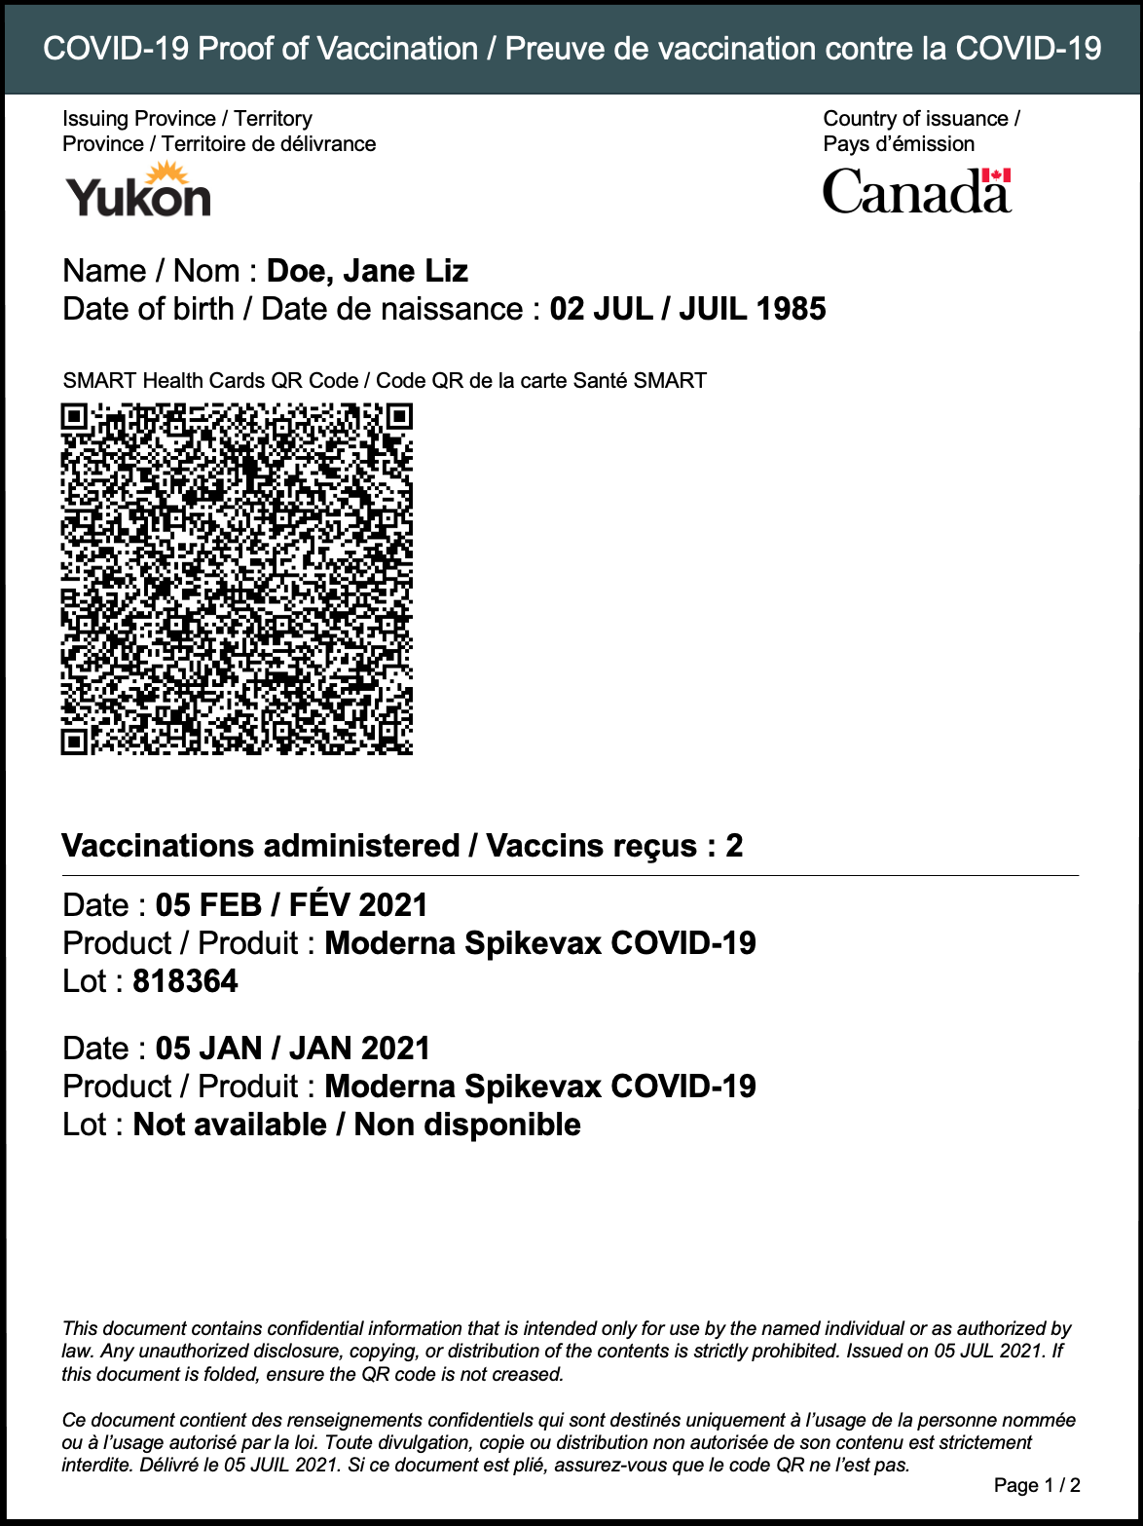  
Figure 1: Domestic Vaccine Certificate Mock-up*

## **Overall Style Guidelines**

The overall PVC document is composed of common core set of pages (at least one) and, optionally, a PT-specific page. The core set of pages will consist of a single page when there are up to two vaccination events. If there are more vaccination events, a vaccine overflow page will be added after the first core page.

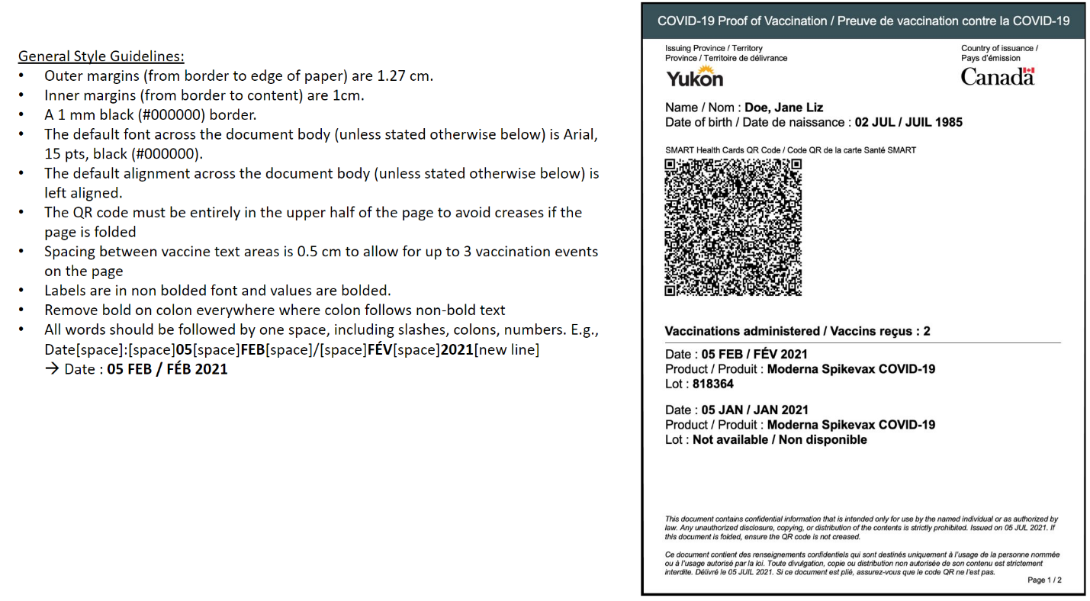

*Figure 2: Domestic Vaccine Certificate Mock-up with Guidelines*

For PVCs representing more than two vaccinations, the overflow page representing the third (and possibly additional) vaccinations should be consistent with the following design:

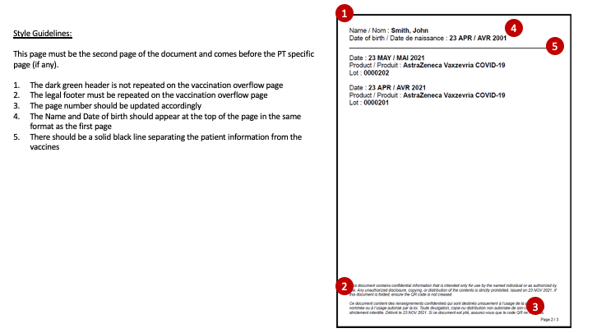

*Figure 3: Vaccine Overflow Page Mock-up with Guidelines*

The PT-specific page, if there is one, will follow the last core page at the PT’s discretion. It may contain guidance and information for the holder. If there is PT-specific information, it must be contained in a page separate from the core page(s).

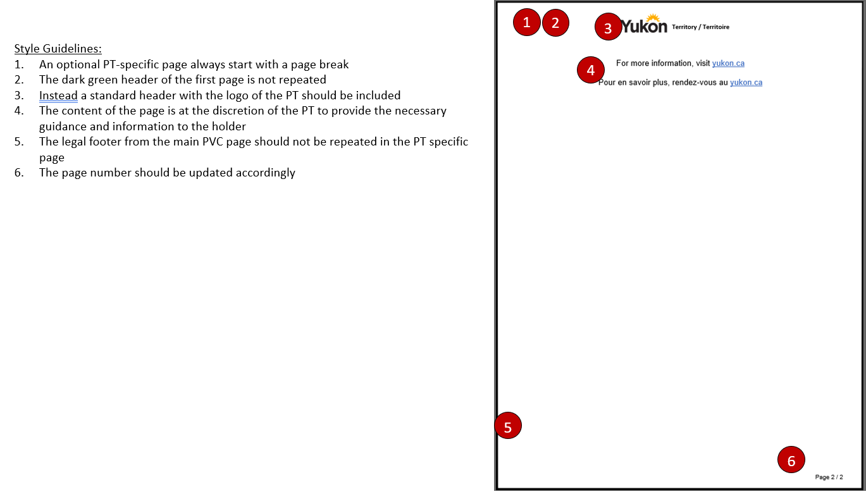

*Figure 4: PT-specific Page Mock-up with Guidelines*

## **PDF Layout**

Layout items below reference SHC data elements in section 4.1.

|  |  |
| --- | --- |
| 1. **Header**, static text, Dark green(#3A5258) background, font – Arial, 15 pts, white (#FFFFFF) text, center aligned, outer & inner margins for this are 0.5 cm. 2. **Issuing PT label**, static text, Arial, 10 pts, black (#000000), left aligned, under the PT logo, (blank section for CAF and GAC) 3. **PT logo**, horizontal format with 1.25 cm height max when printed, left aligned (no logo for CAF and GAC) 4. **Country of issuance label**, static text, Arial, 10 pts, black (#000000), under and left aligned with the Canada wordmark logo 5. **Canada wordmark logo**, 1 cm height when printed, 125mm from the left inner margin 6. **Name**, static text, Arial, 15 pts, followed by Family Name (data element 1.1), Given Name (data element 1.2, with items in the list separated by a space), e.g., “Doe, Jane Liz”. When the given name list is empty, there should be no comma after the family name on the PDF 7. **Date of birth**, static text, Arial, 15 pts, followed by data element 1.3 Birth Date converted from ISO 8601 to the enhanced passport date format described later in section 4.3 (e.g., 2021-02-05 to 05 FEB / FÉB 2021) 8. **SMART Health Card**, Static text, Arial, 10 pts, center aligned above QR code, one a single line 9. **QR code**, 60 mm x 60 mm. 10. **Vaccinations administered**, Arial, 15 pts bolded, black (#000000), followed by the number of vaccinations contained in the QR code. The vaccinations must be listed after this heading in reverse chronological order. 11. **Date**, Arial, 15 pts, followed by data element 2.3 Date of Vaccination converted from ISO 8601 to the enhanced passport date format described later in section 4.3 12. **Product**, Arial, 15 pts, followed by the CDC Product name corresponding to the CVX code of the vaccine (data element 2.2 Vaccine Code). See section 4.6 for additional guidance on representing unknown vaccines. 13. **Lot**, Arial, 15 pts, followed by data element 2.4 Vaccine Lot Number 14. **Repeat 11, 12, 13** for second most recent vaccination, etc. 15. **Legal footer**, static text, Arial, 9 pts, italic, black (#000000), left aligned, 4 pts spacing between English and French texts, and at the bottom of the page, respecting bottom margin of 1 cm. 16. **PVC Issuance date**, Arial, 9 pts, dynamic value representing the date of issuance of the PVC appearing in both French and English in enhanced passport date format. 17. **Page numbering**, Arial, 9 pts, black (#000000), right aligned, 4 mm margins from the bottom border. | *Figure 5: PDF Layout* |

## **Accessibility Standards**

Accessibility standards for the document need to be addressed in compliance with the WCAG standards: PDF Techniques for WCAG 2.0 (<https://www.w3.org/TR/WCAG20-TECHS/pdf>)

The following sections of the WCAG standards are applicable to PT-issued SHC PVCs:

* PDF1 – Adding alt texts to images
* PDF3 – Ensuring reading order in the document  
  e.g., the general reading order should be set through tagging following top down and left to right. In the case of PT and Canada logo, the reading order should be English, French, image alt text.
* PDF7 – Performing OCR on a scanned document; this is handled with the previous PDF3
* PDF8 – Providing definitions for abbreviations
* PDF9 – Providing headings  
  e.g., each heading in the PDF document needs to be specified, for example the “Vaccinations administered” heading should be using H1 header  
  e.g., the header of the PDF document needs to be specified and tagged as a P header so that a screen reader can identify it as such.
* PDF14 - Providing running headers and footers in PDF documents  
  e.g., since the PVC itself is a single page, specify that the header appears only on the first page and is not repeated on every page.
* PDF17 – Specifying consistent page numberings for PDF documents
* PDF18 – Specifying the document title using the Title entry in the document information

Any PT-specific content appended to the standard PVC must also conform to the accessibility standards.

# **Technical Specifications for Data fields**

This section defines the data content and format requirements for the data elements of SHC vaccination certificates issued by PTs.

## **Required Data Elements and Formats**

The tables below represent the data in a flat format. Nonetheless, the SHC JWS payload format needs to be adhered to.  In particular, there are levels such as “meta” and reference sub-objects such as “patient” that need to be included in order for the JSON data structure to be compliant with the SHC standard. Data elements are grouped using two types of FHIR Resources. SMART Health Cards can include one, two or more doses to represent for example booster shots as they become available to the public. See the following SHC specification links: [Vaccination Credential Bundle](http://build.fhir.org/ig/dvci/vaccine-credential-ig/branches/main/StructureDefinition-vaccination-credential-bundle-dm.html#tab-ms), [Patient Profile](http://build.fhir.org/ig/dvci/vaccine-credential-ig/branches/main/StructureDefinition-vaccination-credential-patient-dm.html#tab-ms), [Immunization Profile](http://build.fhir.org/ig/dvci/vaccine-credential-ig/branches/main/StructureDefinition-vaccination-credential-immunization-dm.html#tab-ms).

The PT-issued PVC in Stage B must contain the necessary fields to eventually support the issuance of a federal PVC. Availability of data elements vary between jurisdictions and a common approach to addressing missing data is required.

The tables below specify the requirements for the data fields to be included in the Patient FHIR Resource, Immunization FHIR Resource, and additional PDF fields *not* in the FHIR bundle, respectively.

### **Patient FHIR Resource**

|  |  |  |  |  |  |
| --- | --- | --- | --- | --- | --- |
| **Item #** | **Element** | **Type** | **Specifications** | **Example** | **Default values guidance** |
| **1.1** | Family Name | string | Family name (often called 'Surname’). Should given and family names not be available separately, use the family name field only and leave the Given Names array empty. For a single name e.g., indigenous name, use the family name field and leave the Given names array empty. Length SHOULD be <= 64 | e.g. ‘Doe’  ”family": ”Doe" | Must be included for identity verification. |
| **1.2** | Given Names | Array of strings | Given names, including first name and middle names, if any. If no given name is available provide an empty array as the value of the given name field and refer to 1.1. Length SHOULD be <= 64 | e.g. ‘Jane Liz’  "given": [ ”Jane", ”Liz” ] | Must be included for identity verification. Please see Specifications column |
| **1.3** | Birth Date | date | Full date format YYYY-MM-DD in ISO 8601 | e.g. ‘1985-07-02’  "birthDate": "1985-03-16" | Must be included for identity verification |

### **Immunization FHIR Resource**

|  |  |  |  |  |  |
| --- | --- | --- | --- | --- | --- |
| **Item #** | **Element** | **Type** | **Specifications** | **Example** | **Default values guidance** |
| 2.1 | Security | string | Limited security label to convey identity level of assurance for patient referenced by this resource. To be selected between IAL1.2, IAL1.4, IAL2, IAL3 see [Identity Assurance Level](http://build.fhir.org/ig/dvci/vaccine-credential-ig/branches/main/ValueSet-identity-assurance-level.html) | e.g. for IAL 1.4  "security": [{"system": "https://smarthealth.cards/ial", "code": "IAL1.4"}] | Select the most appropriate but if not known, use “IAL1.4” by default (PT-issued ID was used to verify name and birth date) |
| **2.2** | Vaccine Code | system + code | Vaccine codes can be referenced using the CVX system identified by http://hl7.org/fhir/sid/cvx ([link](https://www2a.cdc.gov/vaccines/iis/iisstandards/vaccines.asp?rpt=cvx) to CVX codes) | e.g. For Pfizer in CVX  "vaccineCode": {    "coding": [ {      "system": "http://hl7.org/fhir/sid/cvx", "code": "208”}]} | CVX is the required system for each vaccine dose. CVX should be placed in first position, additional code systems (e.g., SNOMED) can be added after if required. Further policy guidance is required on the usage of generic CVX codes 500 and 213. They are however not recommended as they may lead to challenges for the holder to prove his/her vaccine status. It is therefore recommended to update the type of vaccine in the system of record first. |
| **2.3** | Occurrence Date | date | Vaccine administration date. All dates SHOULD be represented as using YYYY-MM-DD only (ISO 8601) | e.g. for June 1st, 2021  "occurrenceDateTime": "2021-05-14" | Must be included for each vaccination event, only date is needed |
| **2.4** | Vaccine Lot Number | string | Length SHOULD be <=32 for data minimization. lotNumber SHOULD NOT include `Lot #`, `Lot Number`, etc. Can include special characters including: letters, Latin letters, accented Latin letters, numbers, and special characters. | e.g. for lot number 0123L45A  "lotNumber": "0123L45A" | If unavailable, use instead  "lotNumber": “N/A" to minimize the number of characters in the QR code (the PDF must spell out “Not available / Non disponible") |
| **2.5** | Performer Name | string | Organization which was responsible for vaccine administration. Length SHOULD be <=32 for data minimization. Short, human-readable text representation of the organization. | e.g. for Ontario Ministry of Health  "performer": [ {              "actor": {                "display": ”ON, Canada"   }}]  e.g. for Australian Health Authority  "performer": [ {              "actor": {                "display": ”AUS"   }}] | Performer name should be the two-letter abbreviation of the Canadian province/territory followed by “Canada” for better international visibility (e.g. “ON, Canada”, For inoculations that occurred in foreign jurisdiction, the ISO 3166-1 alpha-3 code  Will be used to identify the country (e.g. “AUS” for Australia. Third and last possible value is “N/A" if the performer name is unavailable. Please note that N/A is used to minimize the number of characters in the QR code. |
| **2.6** | Is Subpotent | boolean | Should only be used in the rare situation where the vaccination is subpotent. In the rare event that the vaccination is subpotent, then ”isSubpotent": true | e.g. for subpotent dose only  ”isSubpotent": true | Always omit the value pair altogether |
| **2.7** | Status | string | The status element indicates if a given Immunization resource represents a completed vaccination, or if the vaccination was not completed for some reason. | e.g. for all doses  "status": "completed" | Must be included always set to “completed” |
| **2.8** | Manufacturer | system + code | Code identifying vaccine manufacturer using system identified by MVX: http://hl7.org/fhir/sid/mvx ([link](https://www2a.cdc.gov/vaccines/iis/iisstandards/vaccines.asp?rpt=mvx) to MVX codes) | e.g. for Moderna in MVX  "manufacturer": {      "identifier": {        "system": "http://hl7.org/fhir/sid/mvx", "value": "MOD" }} | MVX is the required system for manufacturer. The "UNK” code can be used if the manufacturer is unavailable or unknown, however it is not recommended as it may lead to challenges for the holder to prove his/her vaccine status. It is therefore recommended to update the manufacturer in the system of record first. |

**When information is not available** for lot number, vaccine code, manufacturer, please refer to the last column in the above table for guidance.

Where data may not be discernible in source systems, we highly recommend that the source data for these vaccination records be updated to accurately reflect vaccine product (i.e. Moderna, Pfizer, etc.) or a known vaccination administration jurisdiction (i.e. province, territory and Canada or international country). In the case of vaccine product, Canada requires this information as part of the evidence of vaccination in the current COVID-19 Emergency Orders in Council pursuant to the *Quarantine Act* and we are seeing that other international jurisdictions are presenting similar requirements. In the case of administration jurisdiction, it is possible this could be required as part of the evidence of vaccination elements for other international jurisdictions.

## **Sample JWS Payload**

Below is a sample JWS payload:

{

"iss": "https://example.somept.ca/somepath",

"nbf": 1628099964.297,

"vc": {

"type": [

"https://smarthealth.cards#health-card",

"https://smarthealth.cards#immunization",

"https://smarthealth.cards#covid19"

],

"credentialSubject": {

"fhirVersion": "4.0.1",

"fhirBundle": {

"resourceType": "Bundle",

"type": "collection",

"entry": [

{

"fullUrl": "resource:0",

"resource": {

"birthDate": "1985-07-02",

"name": [

{

"family": "Doe",

"given": [

"Jane",

"Liz"

]

}

],

"resourceType": "Patient"

}

},

{

"fullUrl": "resource:1",

"resource": {

"meta": {

"security": [

{

"system": "https://smarthealth.cards/ial",

"code": "IAL1.2"

}

]

},

"lotNumber": "N/A",

"manufacturer": {

"identifier": {

"system": "http://hl7.org/fhir/sid/mvx",

"value": "MOD"

}

},

"occurrenceDateTime": "2021-01-05",

"patient": {

"reference": "resource:0"

},

"performer": [

{

"actor": {

"display": "YT, Canada"

}

}

],

"resourceType": "Immunization",

"status": "completed",

"vaccineCode": {

"coding": [

{

"code": "207",

"system": "http://hl7.org/fhir/sid/cvx"

}

]

}

}

},

{

"fullUrl": "resource:2",

"resource": {

"meta": {

"security": [

{

"system": "https://smarthealth.cards/ial",

"code": "IAL1.2"

}

]

},

"lotNumber": "818364",

"manufacturer": {

"identifier": {

"system": "http://hl7.org/fhir/sid/mvx",

"value": "MOD"

}

},

"occurrenceDateTime": "2021-02-05",

"patient": {

"reference": "resource:0"

},

"performer": [

{

"actor": {

"display": "YT, Canada"

}

}

],

"resourceType": "Immunization",

"status": "completed",

"vaccineCode": {

"coding": [

{

"code": "207",

"system": "http://hl7.org/fhir/sid/cvx"

}

]

}

}

}

],

}

}

}

}

}

*Figure 6: Example of JWS payload*

## **Printed Date Format**

When representing a date in clear text on the PDF, the PVC should follow the ICAO Doc 9303 convention for Machine Readable Travel Documents[1]. For example, using 02 JUL / JUIL 1985 in English and French. Abbreviations are listed in the table below:

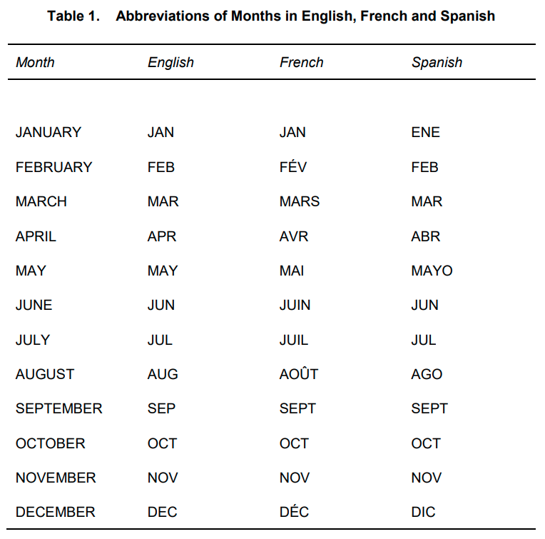

*Figure 7: Abbreviations of Months in English and French*

## **Alpha Code of Provinces and Territories**

As described in section 4.1.2 each vaccination event needs to include a performer name. PTs will be identified by their Alpha Code (Postal/ISO3155-2:CA standard, internationally approved), followed “, Canada” to indicate to verifier the country of provenance. The full list of Alpha Codes is added below for ease of reference:

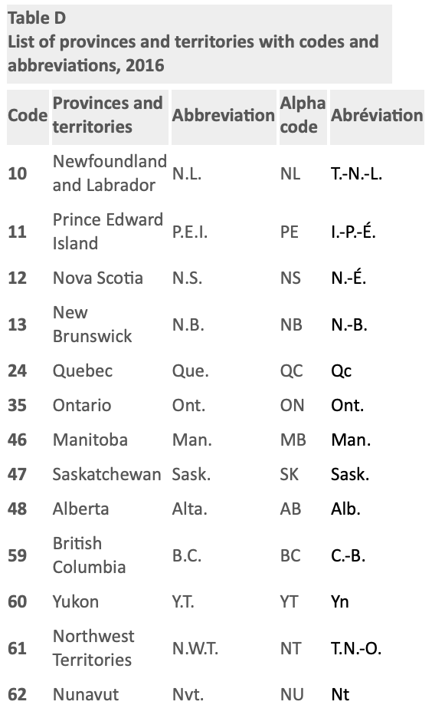

*Figure 8: Alpha Codes of Canadian PTs*

## **Alpha Code of Foreign Jurisdictions**

As described in section 4.1.2 each vaccination event needs to include a performer name. For inoculations that occurred in a foreign jurisdiction, the ISO 3166-1 alpha-3 codes will be used to identify this jurisdiction. For example Australia is referred to as “AUS”. Please refer to the full list found at <https://www.iso.org/obp/ui/#search>

## **Vaccine and Manufacturer Codes**

The CVX and MVX codes appear to be the most descriptive system for coding vaccination and include all the main vaccines that are used in OECD countries. The PVC requires the following naming convention:

* Use in priority the display name of Health Canada approved vaccines [at](https://secure-web.cisco.com/11M4EIaCK7xuRPjERkL7V8g1SQ5keCP9zmhMCZKPiMjUfxkyxQQxWXJXn70Un_z1X8IvtPDQsp32ec1Ykptg8GVS2_YEdIsZ_JCXH5w9Nq65mlD1MOUEHc2yc4TvFEfTomMg_SeqAtqs3S-dIPewrifMPqoZWaLzhUpjiuLuckZ27efjseF61YrMzmyCBiXRLjPx7VE-K0_k8uugBXHuMjJIAsGbGhZq8e8gxgsG5OIIqZvZAaHkKALwA8T5kGY-G7ZwvC70C5iXL_B_0aPNOxiwP5DA54wT0u55HxVqrEVzhr73jAaVljUPPUyN4SMD4/https%3A%2F%2Fwww.canada.ca%2Fen%2Fhealth-canada%2Fservices%2Fdrugs-health-products%2Fcovid19-industry%2Fdrugs-vaccines-treatments%2Fvaccines.html) the following URL: <https://www.canada.ca/en/health-canada/services/drugs-health-products/covid19-industry/drugs-vaccines-treatments/vaccines.html>
* If unavailable, use the display term in the tradename list of the Canadian Vaccine Catalogue at the following URL: <https://cvc.canimmunize.ca/en/explore#/tradenames>
* If unavailable, use the CVX short description [here](https://www2a.cdc.gov/vaccines/iis/iisstandards/vaccines.asp?rpt=cvx) after removing the reference to “non-US” in the name at the following URL: <https://www2a.cdc.gov/vaccines/iis/iisstandards/vaccines.asp?rpt=cvx>

For example, in case of a Moderna vaccine, the QR code will contain the CVX code 207 and the MVX code “MOD”, which has the Health Canada approved name “Moderna Spikevax COVID-19”

|  |  |  |  |  |  |  |  |  |
| --- | --- | --- | --- | --- | --- | --- | --- | --- |
| **CVX Code** | **CVX Short Description** | **CVX Full Vaccine Name** | **Manufacturer** | **MVX Code** | **CDC Product Name** | **SNOMED code** | **Display term in Canadian Vaccine Catalogue** | **To display on PVC** |
| **207** | COVID-19, mRNA, LNP-S, PF, 100 mcg/0.5 mL dose | SARS-COV-2 (COVID-19) vaccine, mRNA, spike protein, LNP, preservative free, 100 mcg/0.5mL dose | Moderna US, Inc. | MOD | Moderna COVID-19 Vaccine (non-US Spikevax) | 28571000087109 | **MODERNA COVID-19 mRNA-1273** | **Moderna Spikevax COVID-19** |

**How to represent unknown vaccines**

*[Additional policy guidance to follow]*

It is possible that vaccination events were added to systems of records without a clear distinction of the vaccine used. PVCs issued with unknown vaccine are not recommended as they may lead to challenges for the holder to prove his/her vaccine status. It is therefore recommended to update the manufacturer in the system of record first and then issue the PVC.

**How to distinguish AstraZeneca and Covishield vaccines**

There is no specific CVX code for the Covishield vaccine – it is the exact same as the AstraZeneca vaccine (a non-replicating viral vector using ChAdOx1) found under the tradenames VAXZEVRIA, AZD1222, ChAdOx1 nCoV-19, and COVISHIELD.

However, the PVC must make a distinction between AstraZeneca and Covishield so that ArriveCAN can apply verification rules that differ between the two. To do so, issuer must include a second vaccine code for each vaccination event corresponding to the CVX code 210 (AstraZeneca). The second vaccine code to use is SNOMEDT CT to be used as follows. The display name is consistent with the Canada Vaccine Catalogue as represented in the example below:

|  |  |
| --- | --- |
| **AstraZeneca**  CVX code: 210  SNOMED CT code: 28761000087108  **Example**  ...  "vaccineCode": {  "coding": [  {  "system": "http://hl7.org/fhir/sid/cvx",  "code": ”210”  },  {  "system": " http://snomed.info/sct",  "code": "28761000087108”  }  ]  },  ...  **Displayed on the PVC:**  Product/Produit: **AstraZeneca Vaxzevria COVID-19** | **Covishield**  CVX code: 210  SNOMED CT code: 28961000087105  **Example**  ...  "vaccineCode": {  "coding": [  {  "system": "http://hl7.org/fhir/sid/cvx",  "code": ”210”  },  {  "system": " http://snomed.info/sct",  "code": "28961000087105”  }  ]  },  ...  **Displayed on the PVC:**  Product/Produit: **Covishield COVID-19** |

*Figure 9: Example of representation of AstraZeneca and Covishield*

PTs are required to add the SNOMED CT code in second position for CVX 210 vaccines and are allowed to add SNOMED CT codes optionally for other vaccines to support additional use cases, for example domestic verification.

The table below summarizes the names of vaccines that are recommended for the PVC and currently in the CVX list. Please note that the general guidance to select the vaccine name will apply in the future as new vaccines emerge and when new CVX codes for COVID-19 vaccines are added.

*Figure 10: List of CVX codes, corresponding MVX codes and names to be displayed on the PVC*

|  |  |  |  |  |  |  |  |  |
| --- | --- | --- | --- | --- | --- | --- | --- | --- |
| **CVX Code** | **CVX Short Description** | **CVX Full Vaccine Name** | **Manufacturer** | **MVX Code** | **CDC Product Name** | **SNOMED code** | **Display term in Canadian Vaccine Catalogue** | **To display on PVC** |
| **207** | COVID-19, mRNA, LNP-S, PF, 100 mcg/0.5 mL dose | SARS-COV-2 (COVID-19) vaccine, mRNA, spike protein, LNP, preservative free, 100 mcg/0.5mL dose | Moderna US, Inc. | MOD | Moderna COVID-19 Vaccine (non-US Spikevax) | 28571000087109 | **MODERNA COVID-19 mRNA-1273** | **Moderna Spikevax COVID-19** |
| **208** | COVID-19, mRNA, LNP-S, PF, 30 mcg/0.3 mL dose | SARS-COV-2 (COVID-19) vaccine, mRNA, spike protein, LNP, preservative free, 30 mcg/0.3mL dose | Pfizer, Inc | PFR | Pfizer-BioNTech COVID-19 Vaccine (Non-US COMIRNATY) | 28581000087106 | **PFIZER-BIONTECH COVID-19 VACCINE mRNA** | **Pfizer-BioNTech Comirnaty COVID-19** |
| **210** | COVID-19 vaccine, vector-nr, rS-ChAdOx1, PF, 0.5 mL | SARS-COV-2 (COVID-19) vaccine, vector non-replicating, recombinant spike protein-ChAdOx1, preservative free, 0.5 mL | AstraZeneca | ASZ | AstraZeneca COVID-19 Vaccine (Non-US tradenames include VAXZEVRIA, COVISHIELD) | 28761000087108    28961000087105  (used to remove ambiguity) | **ASTRAZENECA COVID-19 VACCINE  COVISHIELD** | **AstraZeneca Vaxzevria COVID-19**    **Covishield COVID-19** |
| **211** | COVID-19 vaccine, Subunit, rS-nanoparticle+Matrix-M1 Adjuvant, PF, 0.5 mL | SARS-COV-2 (COVID-19) vaccine, Subunit, recombinant spike protein-nanoparticle+Matrix-M1 Adjuvant, preservative free, 0.5mL per dose | Novavax, Inc. | NVX | Novavax COVID-19 Vaccine | 29171000087106 | **NOVAVAX COVID-19 VACCINE** | **Novavax COVID-19** |
| **212** | COVID-19 vaccine, vector-nr, rS-Ad26, PF, 0.5 mL | SARS-COV-2 (COVID-19) vaccine, vector non-replicating, recombinant spike protein-Ad26, preservative free, 0.5 mL | Janssen | JSN | Janssen (J&J) COVID-19 Vaccine | 28951000087107 | **JANSSEN COVID-19 VACCINE** | **Janssen (Johnson & Johnson) COVID-19** |
| **213** | SARS-COV-2 (COVID-19) vaccine, UNSPECIFIED | SARS-COV-2 (COVID-19) vaccine, UNSPECIFIED | Unknown Manufacturer | UNK | **SARS-COV-2 (COVID-19) vaccine, UNSPECIFIED** | N/A | N/A | **Unspecified COVID-19 vaccine / Vaccin contre la COVID-19 non précisé** |
| **218** | COVID-19, mRNA, LNP-S, PF, 10 mcg/0.2 mL dose, tris-sucrose | SARS-COV-2 (COVID-19) vaccine, mRNA, spike protein, LNP, preservative free, 10 mcg/0.2mL dose, tris-sucrose formulation | Pfizer, Inc | PFR | **Pfizer-BioNTech COVID-19 Vaccine (EUA labeled) COMIRNATY (BLA labeled)** | 33361000087101 | Pfizer-BioNTech Comirnaty COVID-19 mRNA pediatric 5 to 11 years | **Pfizer-BioNTech Comirnaty COVID-19** |
| **219** | COVID-19, mRNA, LNP-S, PF, 3 mcg/0.2 mL dose, tris-sucrose | SARS-COV-2 (COVID-19) vaccine, mRNA, spike protein, LNP, preservative free, 3 mcg/0.2mL dose, tris-sucrose formulation | Pfizer, Inc | PFR | **Pfizer-BioNTech COVID-19 Vaccine (EUA labeled) COMIRNATY (BLA labeled)** | N/A | N/A | **Pfizer-BioNTech Comirnaty COVID-19** |
| **500** | SARS-COV-2 COVID-19 Non-US Vaccine, Specific Product Unknown | SARS-COV-2 COVID-19 Non-US Vaccine, Specific Product Unknown | Unknown Manufacturer | UNK | **COVID-19 Non-US Vaccine, Product Unknown** | N/A | N/A | **Unspecified COVID-19 vaccine / Vaccin contre la COVID-19 non précisé** |
| **501** | COVID-19 IV Non-US Vaccine (QAZCOVID-IN) | SARS-COV-2 COVID-19 Inactivated Virus Non-US Vaccine Product (QAZCOVID-IN) | N/A | UNK | N/A | 33451000087108 | QazCovid-in | **QazCovid-in COVID-19** |
| **502** | COVID-19 IV Non-US Vaccine (COVAXIN) | SARS-COV-2 COVID-19 Inactivated Virus Non-US Vaccine Product (COVAXIN) | Bharat Biotech International Limited | BBI | **COVAXIN (Bharat) COVID-19 Vaccine** | 33211000087105 | COVAXIN | **Covaxin COVID-19** |
| **503** | COVID-19 LAV Non-US Vaccine (COVIVAC) | SARS-COV-2 COVID-19  Live Attenuated Virus Non-US Vaccine Product (COVIVAC) | N/A | UNK | N/A | 33411000087109 | CoviVac | **CoviVac COVID-19** |
| **504** | COVID-19 VVnr Non-US Vaccine (Sputnik Light) | SARS-COV-2 COVID-19 Viral Vector Non-replicating Non-US Vaccine Product (Sputnik Light) | N/A | UNK | N/A | 33461000087106 | Sputnik Light | **Sputnik Light COVID-19** |
| **505** | COVID-19 VVnr Non-US Vaccine (Sputnik V) | SARS-COV-2 COVID-19 Viral Vector Non-replicating Non-US Vaccine Product (Sputnik V) | N/A | UNK | N/A | 31341000087103 | **Sputnik V COVID-19 vaccine** | **Sputnik V COVID-19** |
| **506** | **COVID-19 VVnr Non-US Vaccine (CanSino Biological Inc./Beijing Institute of Biotechnology)** | SARS-COV-2 COVID-19 Viral Vector Non-replicating Non-US Vaccine Product (CanSino Biological Inc./Beijing Institute of Biotechnology) | N/A | UNK | N/A | N/A | N/A | **CanSinoBio COVID-19** |
| **507** | **COVID-19 PS Non-US Vaccine (Anhui Zhifei Longcom Biopharm + Inst of Micro, Chinese Acad of Sciences)** | SARS-COV-2 COVID-19 Protein Subunit Non-US Vaccine Product (Anhui Zhifei Longcom Biopharmaceutical + Institute of Microbiology, Chinese Academy of Sciences) | N/A | UNK | N/A | N/A | N/A | **Anhui Zhifei Longcom COVID-19** |
| **508** | **COVID-19 PS Non-US Vaccine (Jiangsu Province Centers for Disease Control and Prevention)** | SARS-COV-2 COVID-19 Protein Subunit Non-US Vaccine Product  (Jiangsu Province Centers for Disease Control and Prevention) | N/A | UNK | N/A | N/A | N/A | **Jiangsu Province Centers for Disease Control and Prevention COVID-19** |
| **509** | **COVID-19 PS Non-US Vaccine (EpiVacCorona)** | SARS-COV-2 COVID-19 Protein Subunit Non-US Vaccine Product (EpiVacCorona) | N/A | UNK | N/A | 33421000087101 | **EpiVacCorona** | **EpiVacCorona COVID-19** |
| **510** | COVID-19 IV Non-US Vaccine (BIBP, Sinopharm) | SARS-COV-2 COVID-19 Inactivated Virus Non-US Vaccine Product (BIBP, Sinopharm) | Sinopharm-Biotech | SPH | Sinopharm BIBP (BBIBP-CorV) COVID-19 Vaccine | 31301000087101 | **COVID-19 vaccine BIBP** | **Sinopharm BIBP (BBIBP-CorV COVID-19)** |
| **511** | COVID-19 IV Non-US Vaccine (CoronaVac, Sinovac) | SARS-COV-2 COVID-19 Inactivated Virus Non-US Vaccine Product (CoronaVac, Sinovac) | Sinovac | SNV | Coronavac (Sinovac) COVID-19 Vaccine | 31311000087104 | **CoronaVac COVID-19 vaccine** | **Sinovac-CoronaVac COVID-19** |

## **Alternative formats**

### **Mobile optimized layout**

In addition to the letter format PVC which remains the main format, an alternative format for smartphones is available in the Issuer-in-a-Box for PTs that which to offer it. The format uses different layout and proportions so that the holder does not have to zoom, pan the PDF. Please note that this mobile optimized layout can be represented as a PDF that PTs will generate with or without the support of this new feature added in IIAB. The same layout applies to PT-issued wallets where this mobile optimized format should be used in the mobile app. The goal remains for the PVC to be easily recognisable, even across different formats and platform variations.

The mobile optimized PDF:

* Does not replace the original PVC
* Is predominantly used on a smartphone but can also be printed
* Is a single page scrollable PDF and does not include a PT-specific page
* The height of the PDF document is dynamic, it expands as more vaccines are added

**Overview**

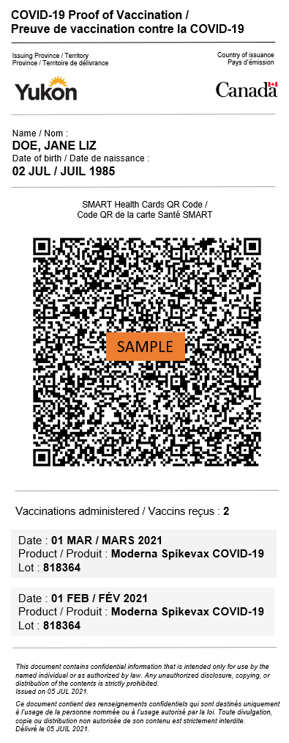

*Figure 11: Mobile optimized PVC mock-up*

**General Style Guidelines**

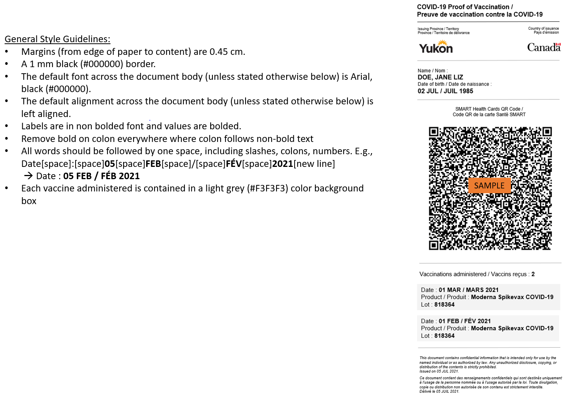

*Figure 12: General Style Guidelines*

**Style guidelines**

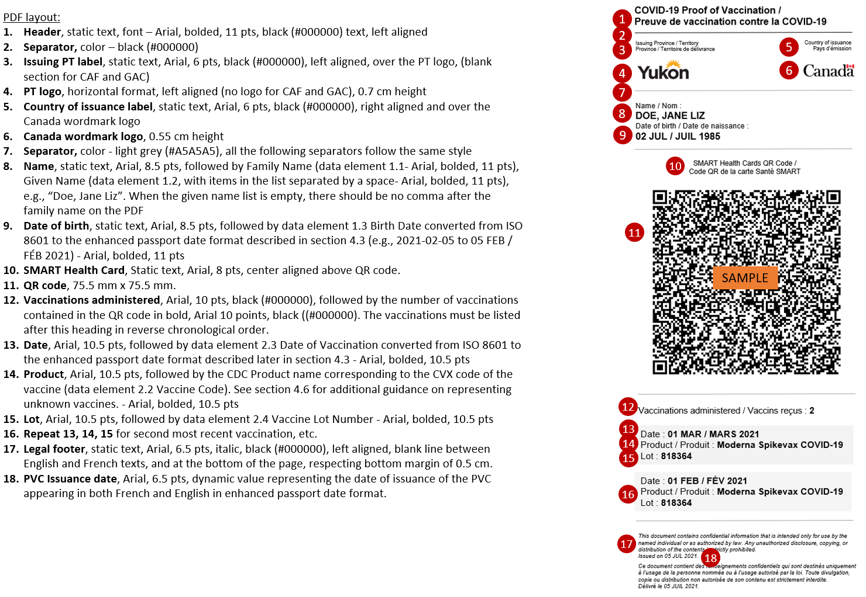

*Figure 13: Style guidelines*

1. https://www.icao.int/publications/Documents/9303_p3_cons_en.pdf